**P6 – Undertake routine network management tasks**

**Creating User Accounts**

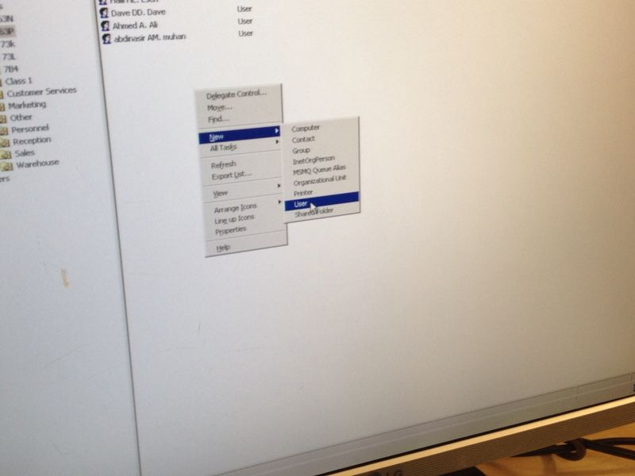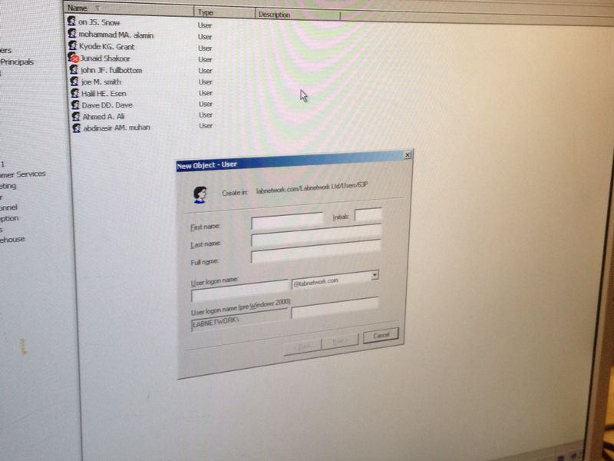To create a user guide is simple. All you have to do is right-click on go on “new” to “user”. Click it and fill in the details of the student. You can create their use logon name. Once you have filled in the details go next, and type the password. Fill it in and it will be complete.

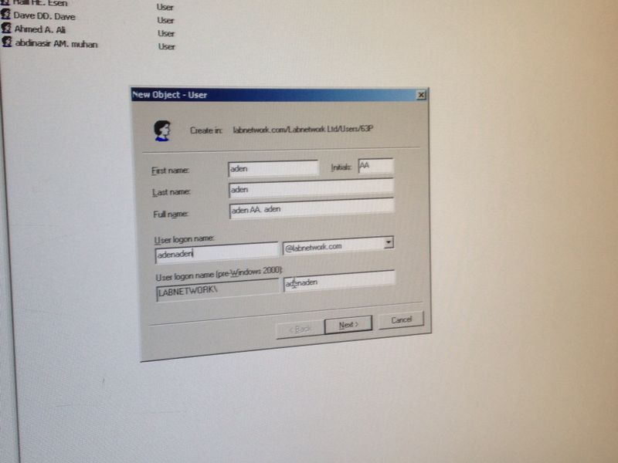

**Reference**

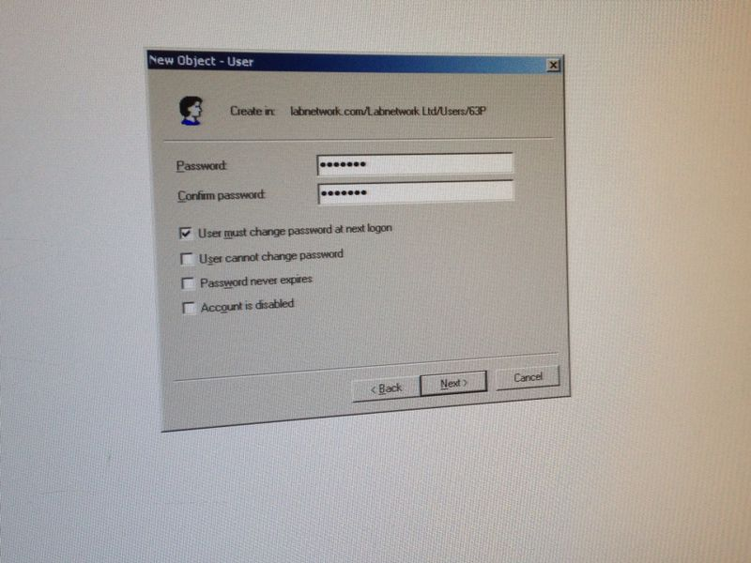

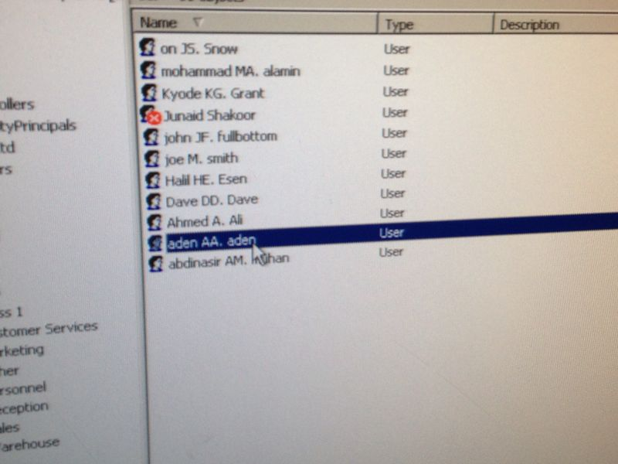

Once it shows on their without any ‘x’, it is complete.

**Back-up procedures**

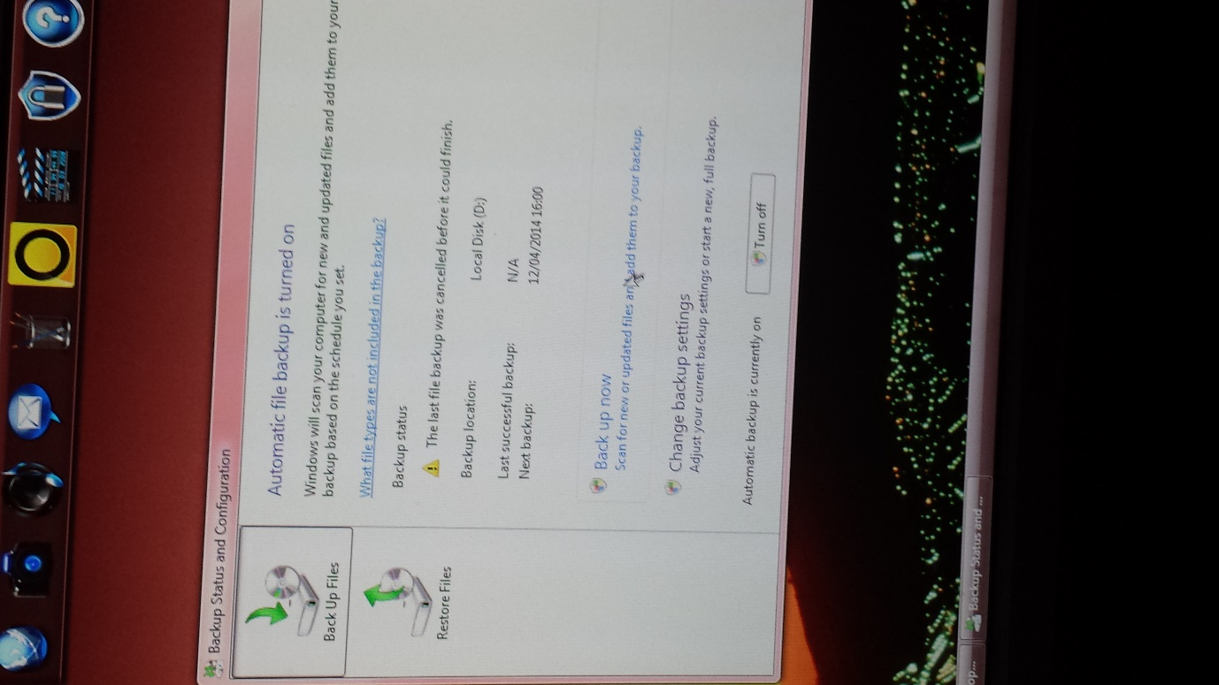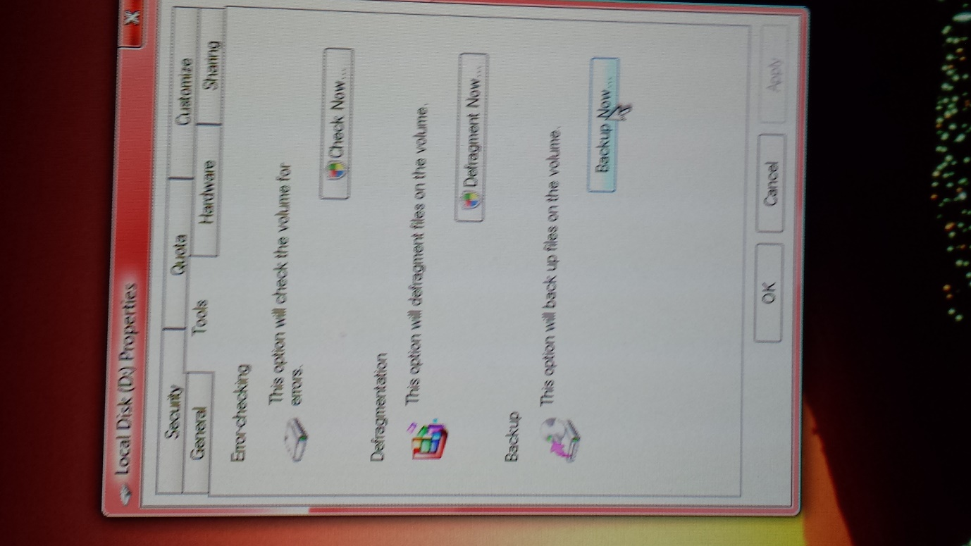It is the same process of getting to this procedure as **defragmentation.** You go on ‘computer’ and right-click on the disk drive. Click on properties and tools. This is where you will reach the stage of where the images shows you. Click ‘Backup now’ to proceed with Back-up. It is quite hard to navigate around of how to Back-up. You have to turn on the Automatic backup. This will enable the ‘Back up now’ sign and once you click on it, it would start to back-up your disk.

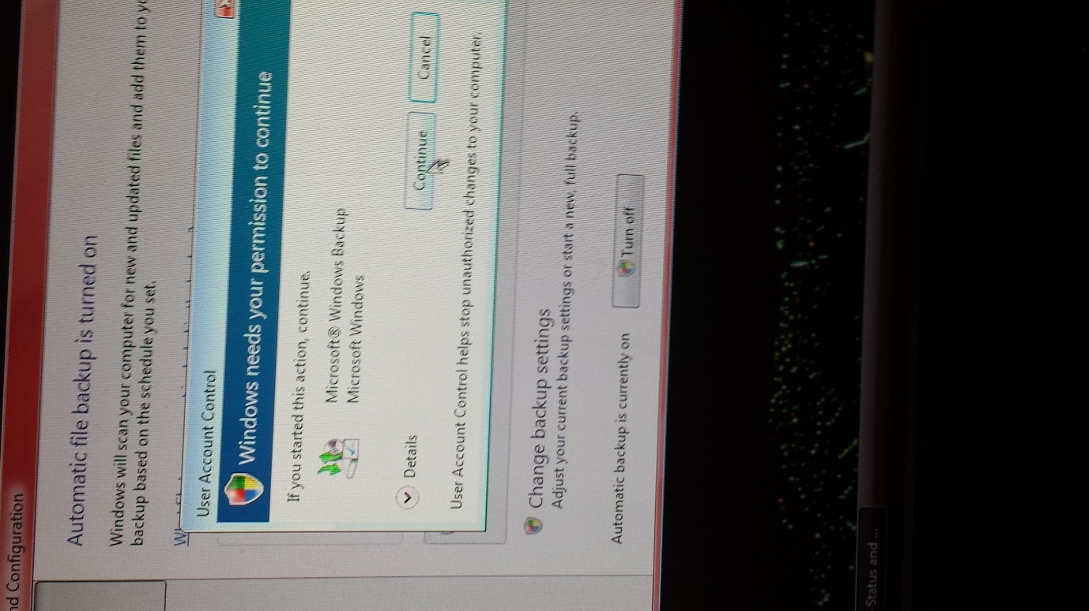As always, you need permission to continue. If it were necessary, you would need to put the administration password into it. Continue and proceed with the procedure.

**IT WILL BE COMPLETED ONCE THE GREEN LIGHT HAS BEEN FILLED.**

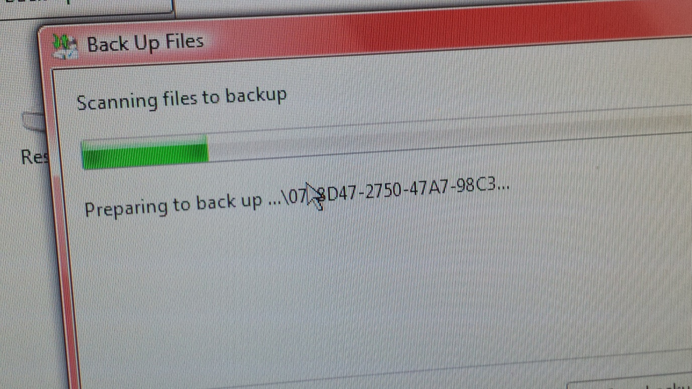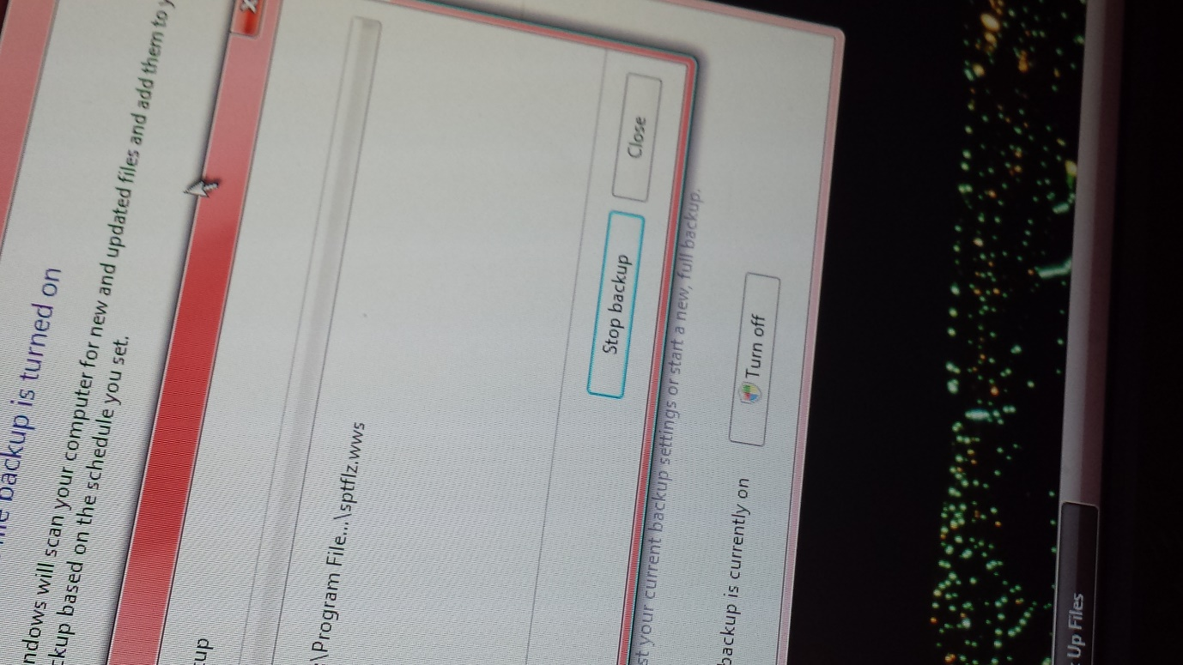

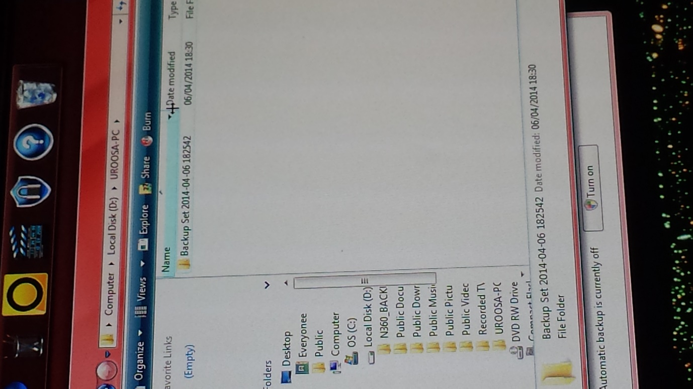As you can see in this image, all the BACK-UP is stored in this place. It gives a clear date of when the data was backed-up.

**Configuring Anti-Virus Options**

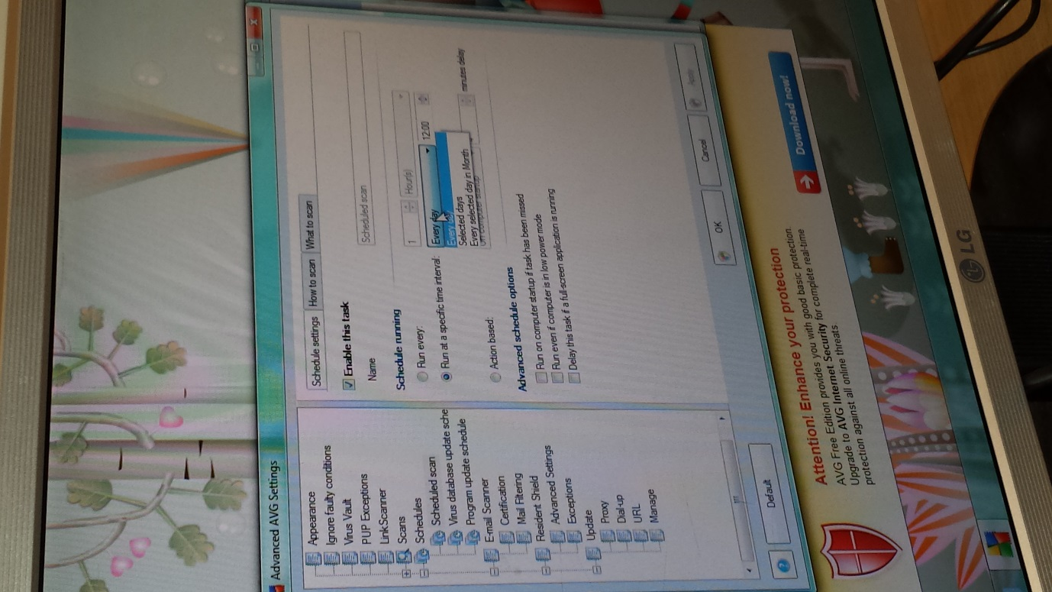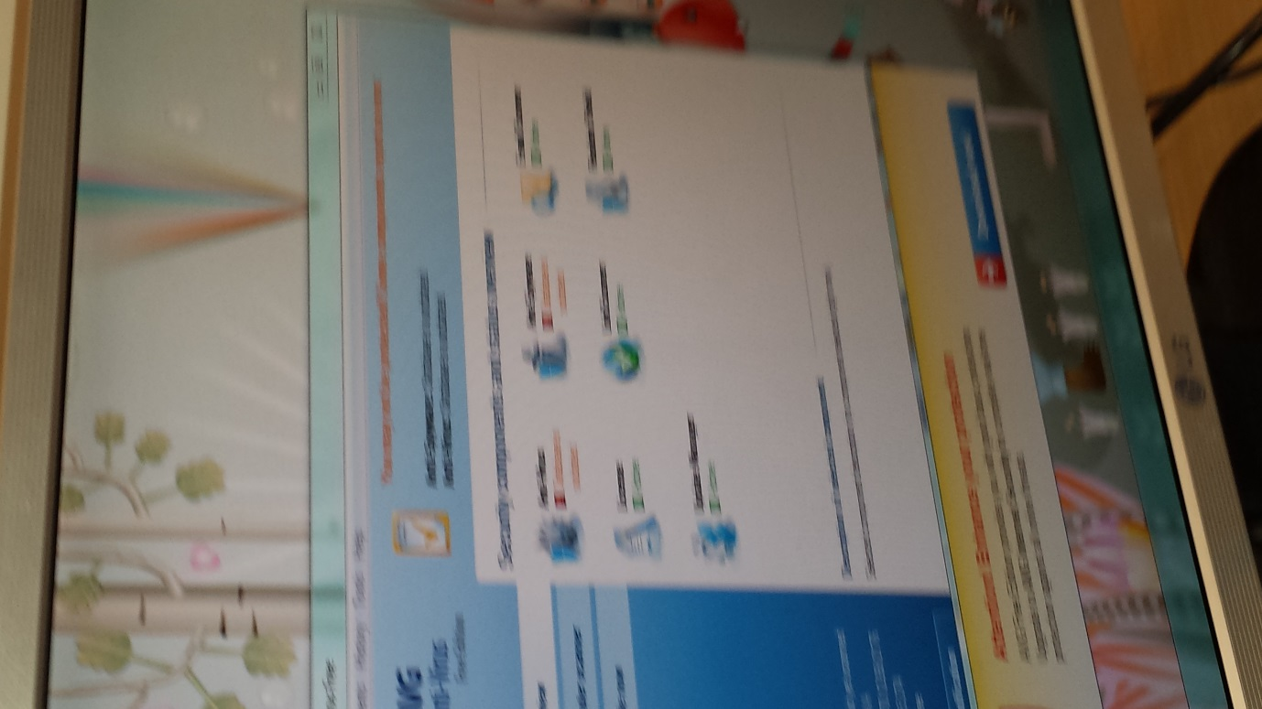In this part, we will make configure with the AVG anti-virus. We will need to go on Tools, Settings and Advance Settings. We will need to make the scan a specific timing for the AVG scan to occur e.g. scan only on Tuesdays. We scheduled the scan by every day and selected days, Monday and Wednesday. The timings is 18:00 (6PM). Once you have followed these procedures, it will scan on the selected time and day.

